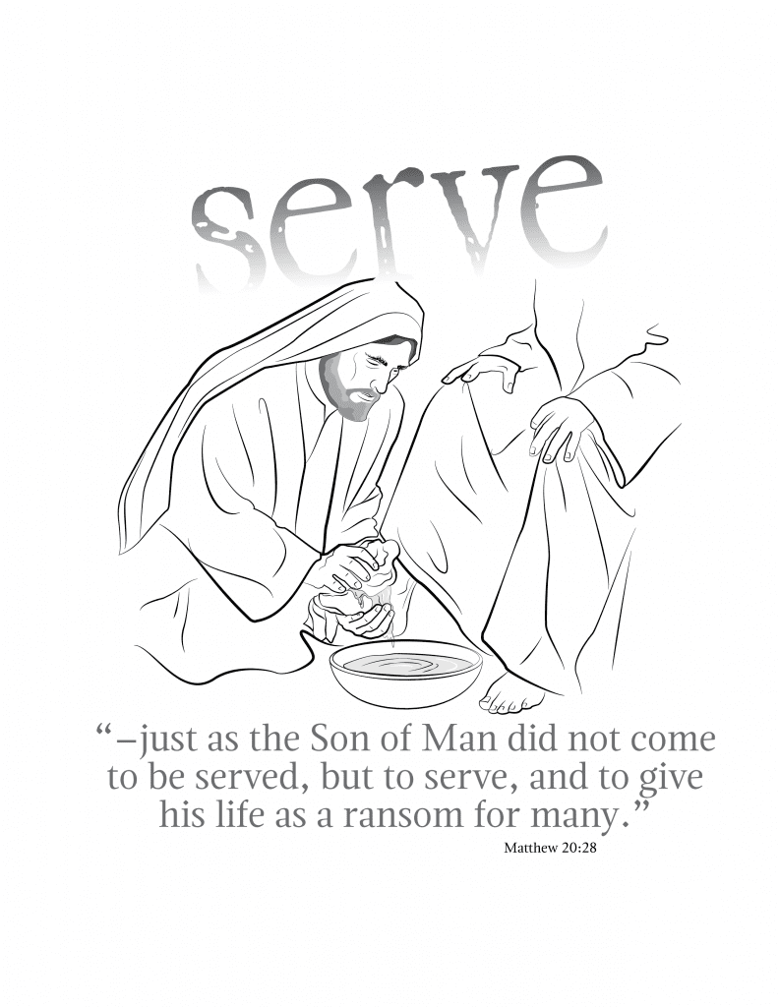

October 20, 2024

Good Hope Lutheran Church

TWENTY SECOND SUNDAY AFTER PENTECOST
WITH ONE VOICE: SERVICE OF THE WORD
October 20, 2024
10:30 a.m.

The Prelude & Meditation
The Ringing of the Bell
The Welcome & Announcements
The Spark Choir
*The Hymn “You Servants of God” LBW #252
*The Greeting WOV page 46
*The Scripture Song WOV page 47
*The Prayer of the Day (in unison)
Sovereign God, you turn your greatness into goodness for all the peoples on earth. Shape us into willing servants of your kingdom, and make us desire always and only your will, through Jesus Christ, our Savior and Lord. Amen.

The First Reading -Job 38:1-7; 34-41
¹The Lord answered Job out of the whirlwind: ²“Who is this that darkens counsel by words without knowledge? ³Gird up your loins like a man, I will question you, and you shall declare to me. ⁴“Where were you when I laid the foundation of the earth? Tell me, if you have understanding. ⁵Who determined its measurements—surely you know! Or who stretched the line upon it? ⁶On what were its bases sunk, or who laid its cornerstone ⁷when the morning stars sang together and all the heavenly beings shouted for joy?
³⁴“Can you lift up your voice to the clouds, so that a flood of waters may cover you? ³⁵Can you send forth lightnings, so that they may go and say to you, ‘Here we are’? ³⁶Who has put wisdom in the inward parts, or given understanding to the mind? ³⁷Who has the wisdom to number the clouds? Or who can tilt the waterskins of the heavens, ³⁸when the dust runs into a mass
and the clods cling together? ³⁹“Can you hunt the prey for the lion, or satisfy the appetite of the young lions, ⁴⁰when they crouch in their dens, or lie in wait in their covert? ⁴¹Who provides for the raven its prey, when its young ones cry to God, and wander about for lack of food?”
L: “The Word of the Lord” C: “Thanks be to God”

The Psalm -Psalm 104:1-9, 24, 35C
¹Bless the Lord, O my soul; O Lord my God, you are very great! You are clothed with majesty and splendor.
²You wrap yourself with light as with a cloak and stretch out the
heavens like a tent.
³You lay the beams of your chambers in the waters above; you make the clouds your chariot; you ride on the wings of the wind.
⁴You make the winds your messengers and flames of fire your
servants.
⁵You set the earth upon its foundations, so that from now until forever it shall never be moved.
⁶You covered it with the deep as with a garment; the waters stood
above the mountains.
⁷At your rebuke the waters fled, scattered by your voice of thunder.
⁸They went up into the mountains and descended down to the
valleys, to the place where you assigned them.
⁹You set the limits that they should not pass; never shall they return to cover the earth again.
²⁴How manifold are your works, O Lord! In wisdom you have
made them all; the earth is full of your creatures.
^{35b}Bless the Lord, O my soul. Hallelujah!

The Hymn “Jesu, Jesu, Fill Us with Your Love” WOV #765
(NOISY OFFERING FOR WORLD HUNGER)
The Second Reading -Hebrews 5:1-10
¹Every high priest chosen from among mortals is put in charge of things pertaining to God on their behalf, to offer gifts and sacrifices for sins. ²He is able to deal gently with the ignorant and wayward, since he himself is subject to weakness; ³and because of this he must offer sacrifice for his own sins as well as for those of the people. ⁴And one does not presume to take this honor, but takes it only when called by God, just as Aaron was. ⁵So also Christ did not glorify himself in becoming a high priest, but was appointed by the one who said to him, “You are my Son, today I have begotten you”;
⁶as he says also in another place, “You are a priest forever, according to the order of Melchizedek.” ⁷In the days of his flesh, Jesus offered up prayers and supplications, with loud cries and tears, to the one who was able to save him from death, and he was heard because of his reverent submission. ⁸Although he was a Son, he learned obedience through what he suffered; ⁹and having been made perfect, he became the source of eternal salvation for all who obey him, ¹⁰having been designated by God a high priest according to the order of Melchizedek.
L: “The Word of the Lord” C: “Thanks be to God”

*The Gospel Acclamation WOV page 48
*The Response before the Gospel
All: “Glory to you, O Lord”
*The Gospel -Mark 10:35-45
³⁵James and John, the sons of Zebedee, came forward to him and said to him, “Teacher, we want you to do for us whatever we ask of you.” ³⁶And he said to them, “What is it you want me to do for you?” ³⁷And they said to him, “Grant us to sit, one at your right hand and one at your left, in your glory.” ³⁸But Jesus said to them, “You do not know what you are asking. Are you able to drink the cup that I drink, or be baptized with the baptism that I am baptized with?” ³⁹They replied, “We are able.” Then Jesus said to them, “The cup that I drink you will drink; and with the baptism with which I am baptized, you will be baptized; ⁴⁰but to sit at my right hand or at my left is not mine to grant, but it is for those for whom it has been prepared.”
⁴¹When the ten heard this, they began to be angry with James and John. ⁴²So Jesus called them and said to them, “You know that among the Gentiles those whom they recognize as their rulers lord it over them, and their great ones are tyrants over them. ⁴³But it is not so among you; but whoever wishes to become great among you must be your servant, ⁴⁴and whoever wishes to be first among you must be slave of all. ⁴⁵For the Son of Man came not to be served but to serve, and to give his life a ransom for many.”
Response after the Gospel All: “Praise to you, O Christ”

The Children’s Message
The Sermon “God won’t let go”
The Hymn “You Who Dwell in the Shelter of the Lord” WOV #779
*The Response to the Word WOV page 49
*The Exchange of Peace
The Offering
The Offertory WOV page 50
*The Prayers of the People WOV page 52
*The Lord’s Prayer WOV page 52
*The Blessing & Dismissal WOV page 53
*The Sending Hymn
“The Spirit Sends Us Forth to Serve” WOV #723
*The Postlude

Portions from sundaysandseasons.com. Copyright © 2024 Augsburg Fortress. All rights reserved. Reprinted by permission under Augsburg Fortress Liturgies Annual License #SAS019406. All rights reserved. music used under OneLicense #A719753

WELCOME to all who have joined us for worship this morning. If you are a visitor, please sign the guest registry and do come visit us again. May the Lord bless each of us.

THE OFFERING today is for Current Expenses. The offering next Sunday is for Benevolence.

PASTOR JOHN’S OFFICE HOURS
Mon. 9:30-12:30 at Immanuel, Tues. 9:30-12:30 at St. John’s,
and Wed. 9:30 to 12:30 at Good Hope.

THIS WEEK AT GOOD HOPE
Mon., Oct. 21 6:30 p.m. Bible Study @ Immanuel
(Bring a bible)
Wed., Oct. 23 3:00 p.m. Worship @ Summit House
Sun., Oct. 27 9:15 a.m. Sunday school
9:30 a.m. Senior Choir Practice
10:30 a.m. Worship/Holy Communion

PARENTS OF SUNDAY SCHOOL AGED CHILDREN
We invite you to drop your children off for Sunday School and stay for coffee and fellowship in the chapel during Sunday School hour. Coffee, bottled water, and card games will be provided. Visit with fellow parents and then please join us for worship at 10:30 a.m.

OUR ANONYMOUS DONOR continues to bless us with their generosity! The donor has agreed to continue giving matching funds throughout the month of October, to help the Friends of the Care Center Hail Mary Fund. This enables us to help the care center remain financially sound. Please remember to give generously to the Friends of the Care Center Hail Mary Fund. We are currently at 19 residents.

ST. JOHN’S PERPETUAL NEEDS FUND COMMITTEE
St. John’s is holding their annual wreath sales. Orders are due by Sunday, November 3rd. Please pay for your wreath in advance. Make checks payable to St. John’s PNF. There are envelopes in the back to put your order form and money into. The PNF fund helps families in the area who are in dire need of assistance. Deliveries will be prior to Thanksgiving and delivered to Good Hope. Please pick up your wreaths during office hours. (Tues-Fri morning from 9:00-noon). Thank you!
WE ARE LOOKING FOR volunteers run the camera for video taping our church services. If interested please let Pastor John or Brad Bengtson know. Thank you!
OPERATION CHRISTMAS CHILD
It is that time of year again to pack shoeboxes! Last year more than 10.5 million shoeboxes were packed and donated to children around the world. In the midst of fear and uncertainty, the needs are greater than ever before to share the Good News of Christ! Please help us in spreading the gospel of Jesus Christ through Operation Christmas Child.
Pick up a shoebox in the entryway, and fill it with fun toys, hygiene items, school supplies and accessories. Return to church by November 24th, and please remember to include $10.00 for shipping. Thank you so much for your help and sharing God’s love with others.

PRAISE GOD FROM WHOM
ALL BLESSINGS FLOW

October launches members of Good Hope into our annual
CORN AND CASH INGATHERING

This is a special time for us. A time to take stock of all the things we have been blessed with-and we have all been richly blessed! To show our thanks to God, please contribute generously to the workings of the church.

You may leave a corn donation at the elevator, place it in the offering plate on Sunday morning in an envelope marked “Cash Offering” or left in Gloria Bartelt’s mailbox.

Contributions will be used for Current Expenses.

“For the harvests of the Spirit, Thanks be to GOD.
For the good we all inherit, Thanks be to GOD.
For the wonders that astound us,
For the truths that still confound us,
Most of all that love has found us,
Thanks be to GOD.”



